***Business Intelligence Design Interface at different levels***

**Introduction -**

This report will be covering the use of business intelligence tools and technologies associated with it. This report will discuss the choice for dashboards/visuals to help management in their decision-making process.

**B.I Operational, Tactical and Strategic levels of different customization which have been integrated into the design -**

The three types of planning used by managers, including strategic, tactical and operational. Terms, such as single-use plans, continuing plans, policy, procedure and rules, will also be defined.

There are three main types of strategies that the director will use to achieve organisation targets, namely organisational, logistical and strategic priorities. If you think of these three types of plans as stepping stones, you can see how their relationship with each other helps to achieve organisational goals.

Operational strategies are necessary to ensure that operational objectives and functional measures contribute to the realisation of strategic plans. Instead, in typical strategy style, there are arrangements to back up projects that collapse. These are alluded to as contingency plans.

For better understand how executives use each type of plan, let's take a look at Nino's Pizzeria's example and how Tommy, Martha and Frank carry out their scheduling activities.

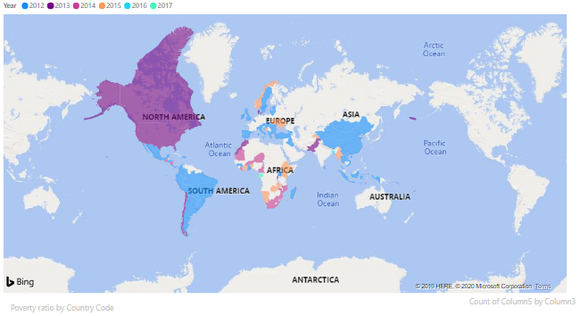

**Operational Management Level -**

The organisational tier is associated with the organization's day-to-day business transactions.

Definitions for users at this level of management include cashiers at the point of sale, bank tellers, medical workers, customer service staff, etc. Users at this stage make systematic choices. This indicates that they have established laws that govern them when making decisions.

In this case, WFP sells goods on loan and has a lending plan that has a set borrowing limit. Both salespeople need to consider whether or not to give credit to the consumer is based on the current credit information given by the programme.

Operational proposals are situated at the bottom of the totem pole; these are plans made for frontline or low-level supervisors. Both organisational strategies concentrate on the specific procedures and operations that take place at the lowest level of the enterprise. Managers will organise the routine tasks of the team with a high level of detail.

Operational management tasks for WFP would include such items as organising staff on a weekly basis; reviewing, purchasing and stocking inventories; preparing a monthly budget; designing a quarterly advertising advertiser to increase sales of a particular product or specifying the employee's performance targets for the year.

Operational projects can be either single-use or continuing. Single-use contracts are those that are meant to be used only once. These contain things that would not be replicated and often have an expiration date.Creating a monthly budget and developing a quarterly promotional advertisements to increase sales of a particular product are examples of how employees would use single-use planning.

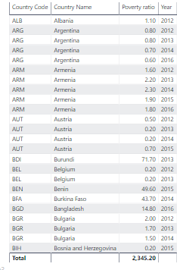

**Tactical Management Level -**

This stage of organisation is controlled by middle-level administrators, department heads, supervisors, etc. Users at this level usually control the operations of users at the stage of organisational management.

Semi-structured decisions are made by tactical clients. Decisions are based, in part, on established criteria and judgmental calls. As an example, a tactical director may review the customer's credit limit and payment history and decide to make an exception in order to increase the credit limit for a particular customer.

The policy was partly formulated in the context that the strategic planner must use current information to identify the payment history that supports the company and the percentage increase required.

Organizational strategies help strategic plans by converting them into specific plans applicable to a specific area of the enterprise. The organisational proposals is associated with the obligation and efficiency of the lower-level teams to carry out their sections of the strategic plan.

In the case, as managers, WFP’s middle-level boss, hears of WFP's ambitious plan to increase profitability, Martha quickly begins to think of future operational strategies to ensure that this works.

Tactical preparation for the manager could include items like testing a new pie-making process that has been tested to shorten the time and find ways to better monitor delivery routes and drivers.

As a proactive strategist, the Manager needs to create a series of measured steps that require a shorter time and are smaller in nature than the strategic plan, but still help to bring the enterprise back to the long-term goal.

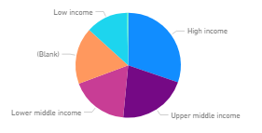

**Strategic Management Level -**

This is the highest level in an organisation. Users at this stage take unstructured decisions. Senior level executives were involved with the organization's long-term planning. We leverage input from strategic administrators and external knowledge to help them in making unstructured decisions.

Action strategies were built with the whole WFP in mind and start with the purpose of the organisation. Top-level executives, such as CEOs or leaders, must design and implement strategic plans that paint a picture of the organization's ideal future and long-term goals. Essentially, strategic plans are looking ahead to where the company needs to be in three, five, and even ten years. Strategic plans, which are developed by top-level administrators, act as a basis for low-level preparation.

In the case, The WFP’s top manager. As a top-level executive, They must use strategic planning to insure that the organization's long-term priorities are achieved. For WFP, it means developing long-term approaches to drive prosperity, improve productivity and efficiency, raise investment returns, enhance customer service and find ways to give back to the community in which it exists.

WFP's strategic plans to accelerate prosperity, improve productivity and efficiency and raise investment returns are all part of the expected future of the countries. Strategic plans often tend to require multi-level participation so that each group of the company plays a significant role in meeting the strategically targeted objectives. Top-level executives, such as Tommy, establish strategic goals so that middle-and lower-level managers may create consistent strategies associated with those priorities.

**Conclusion -**

In conclusion this repost talks about the use of business intelligence tools and technologies associated with it. This report will discuss the choice for dashboards/visuals to help management in their decision-making process.

**References -**

Tableau Software. (2020). *What is business intelligence and why does it matter?*. [online] Available at: https://www.tableau.com/en-gb/learn/articles/business-intelligence [Accessed 26 Jan. 2020].